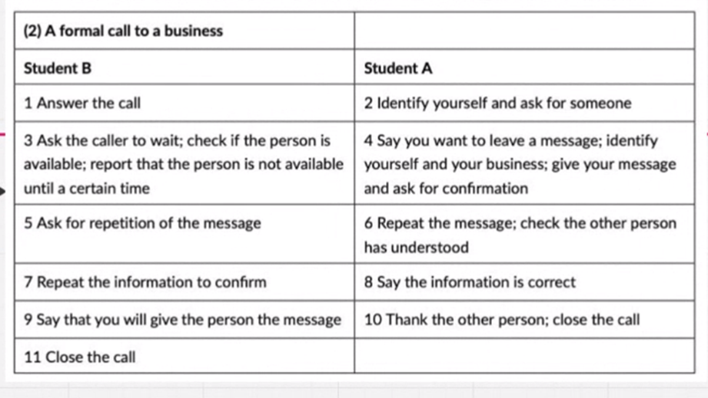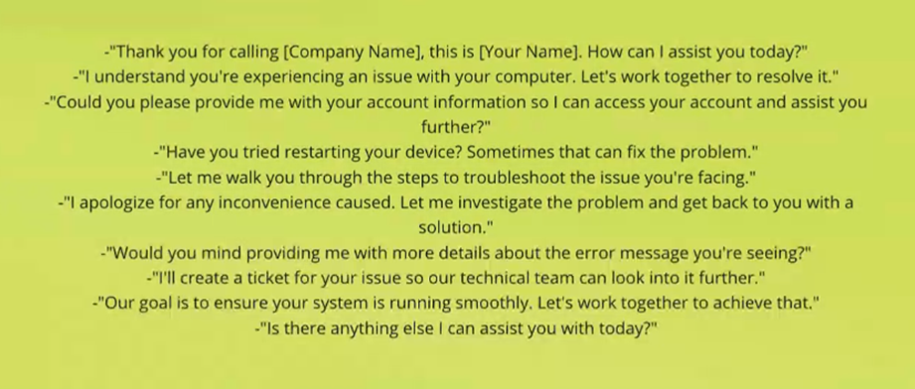

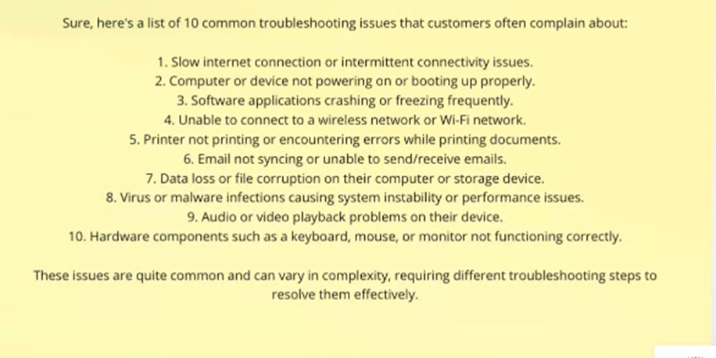

A: Thank you for calling Claro, this is Alejandra, how can I help you?

B: Hello Alejandra, my name is Stefania, I am having an issue connecting to the wifi network on my laptop.

A: I understand you’re having trouble connecting to your wifi, is that correct?  
B: yes, that 's it.

A: Let’s work together to resolve it. Have you tried restarting your laptop? Sometimes that fixes the problem.

B: Yes, I already tried that before calling, but it didn’t work.  
A: Alright, then let’s try restarting your modem, please push the power button and wait a few seconds, then turn it back on. Let me know when it’s done.

B: Alright let me try………. okay, it’s back on.

A: Nice, please try connecting the wifi once more.  
B: Wow, that worked, you’re amazing.

A: Great! Can I help you with anything else?  
B: no, thank you, bye.  
A: you’re welcome, thank you for calling Claro.

Participants: Alejandra Amortegui - Stefanía Gómez